CSC-289

Bombastic Bookstore

**Bombastic Book Store User Manual**

Table of Contents

**Introduction**

**Purpose of this document**

**Getting Started**

**System Requirements**

**Exploring the Application**

**Main Page and Navigation Bar**

**Finding and Adding Books**

**Updating Quantities**

**Settings**

**User Report**

**About Us**

**Troubleshooting**

**FAQ**

**Support and Contact Information**

**CSC-289 Programming Capstone Project**

**Project Name:** Bombastic Bookstore Inventory Management System

**Team Number:** Group 2

**Team Project Manager:** Brandon Biggs

**Team Members:** Brandon Biggs, Julia McDonald, Ryan Burres, James Dove, Jaylan Chavis, Joshua Macy

**Bombastic Bookstore User’s Manual**

**Introduction**

**Purpose of This Document**

The purpose of this document is to aid with problems that occur while implementing and operating the application. In addition, this document provides information on system specification for the application to perform at its best to prevent problems. The document is intended for anyone using the application.

**Getting Started**

**System Requirements**

**Hardware**

An up-to-date desktop or laptop device is needed to run this application. The devices should include the following specifications:

* A secure internet connection
* At least 64 GB of storage
* At least 4 GB of ram
* 1 GHz or faster processor with at least 2 cores

**Software**

The software necessary to run this application will be an up-to-date browser and operating system. This system can run on most browsers and operating systems. However, for the best results use a device with Windows 11 and either Chrome or Microsoft Edge as the internet browser.

**Logging In**

To start using the Bombastic Bookstore Inventory Management System, follow the steps below:

1. Start by running the application from the command line.
2. Log in using your username and password. If you are a first-time user sign up using your email.
3. When logged in you will arrive at the home page of the application.

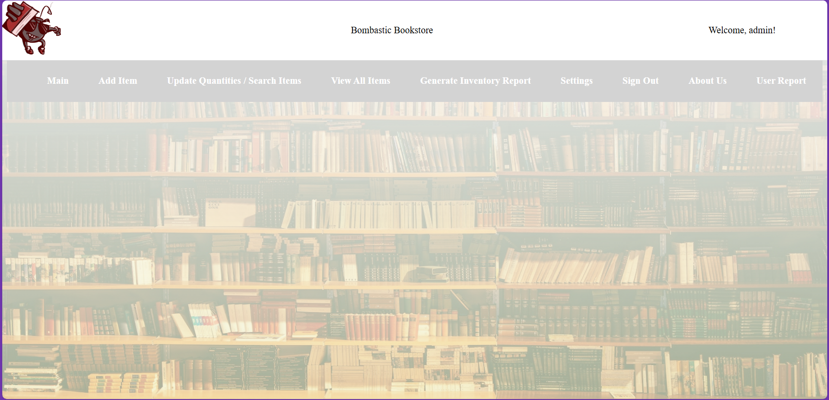

**Application Overview**

**Main Page and Navigation Bar**

Here on the main page, you will have a navigation bar that will be on each page to navigate between all the features in the application



**Finding and Adding Books**

To find and add books follow the steps below:

1. Click on the Add Item tab on the navigation bar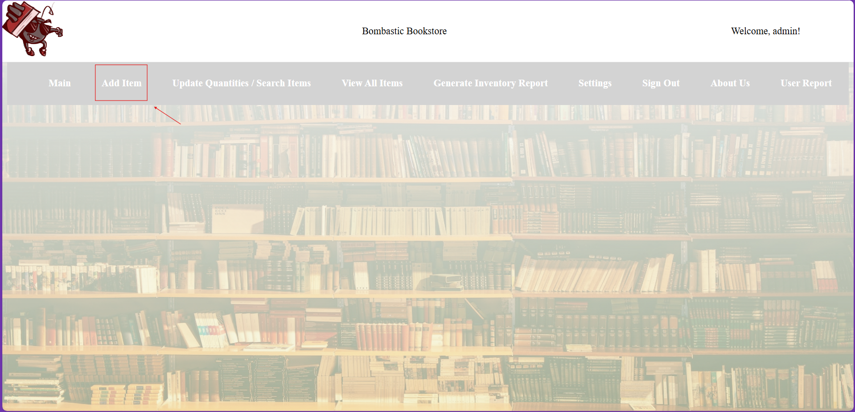

You will arrive at the Add Items Page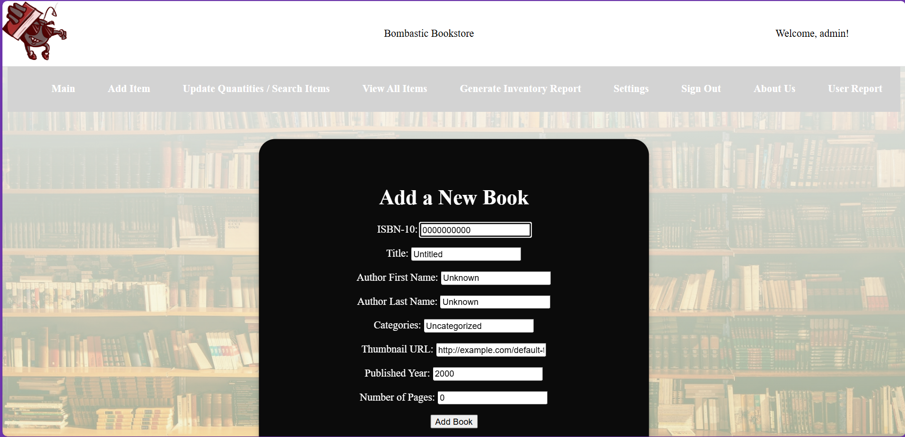

1. Enter the required book information into the form 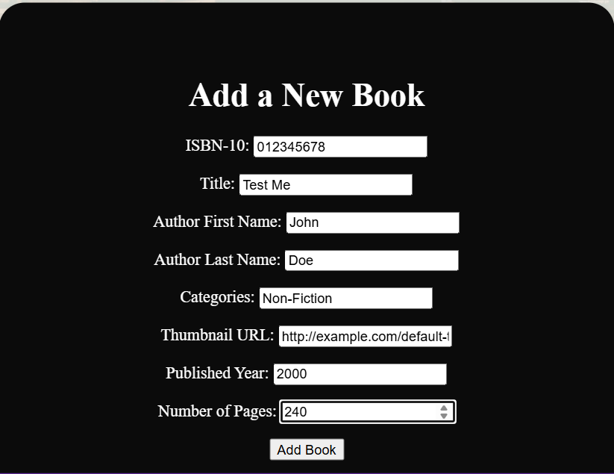Then click Add Book at the bottom of the form.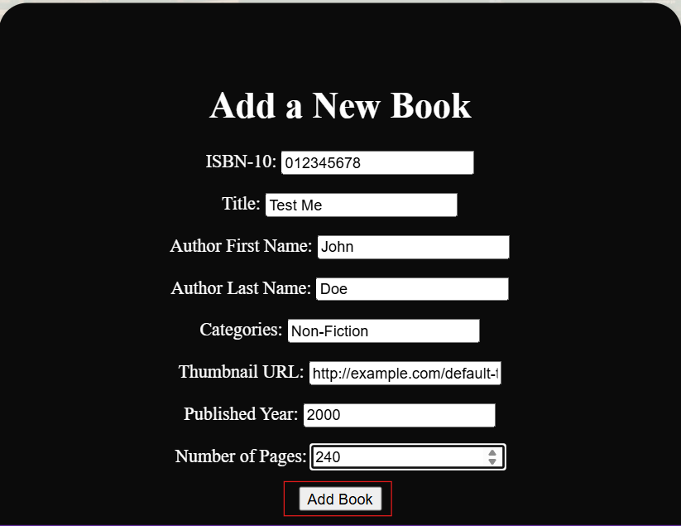
2. Click on the Update Quantities/Search Items to find the book to see if it has been successfully added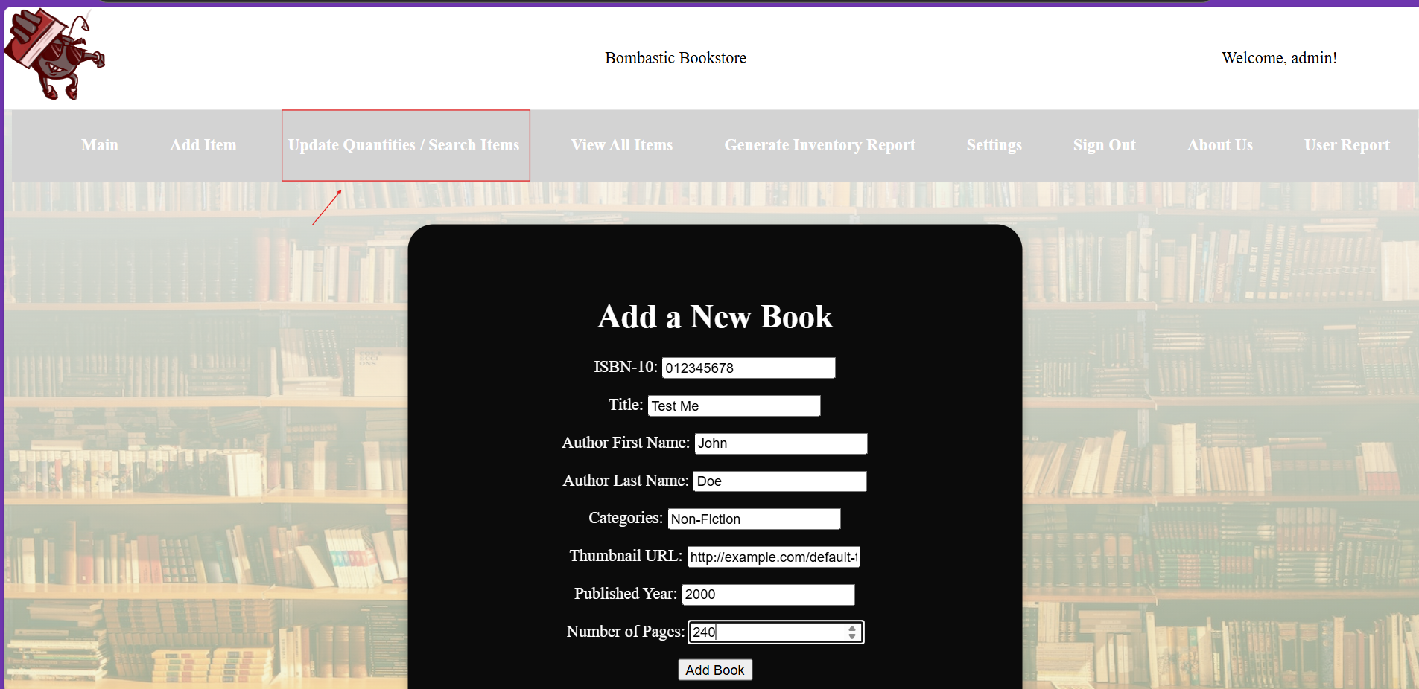
3. Enter the book title into the search prompt and press the ENTER key.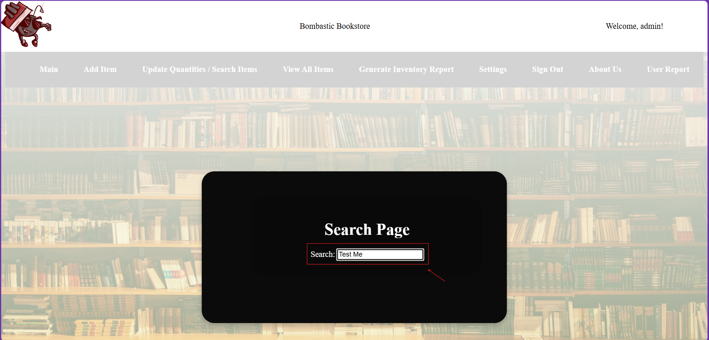
4. Here we see that our book has been successfully added to the inventory.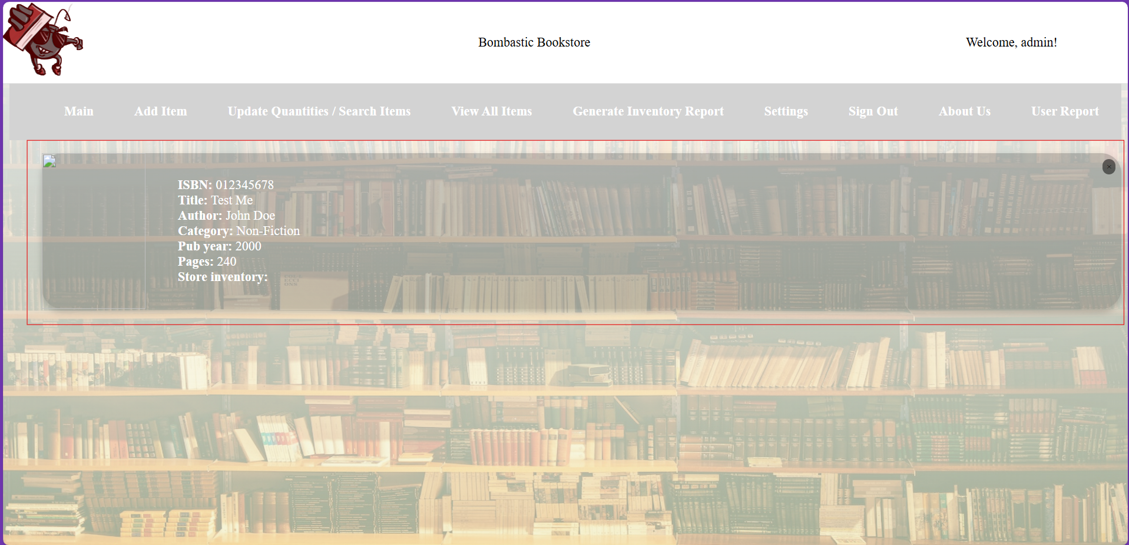

**Updating Quantities**

To update the quantity of the books:

1. Click on the View All Items tab in the navigation bar

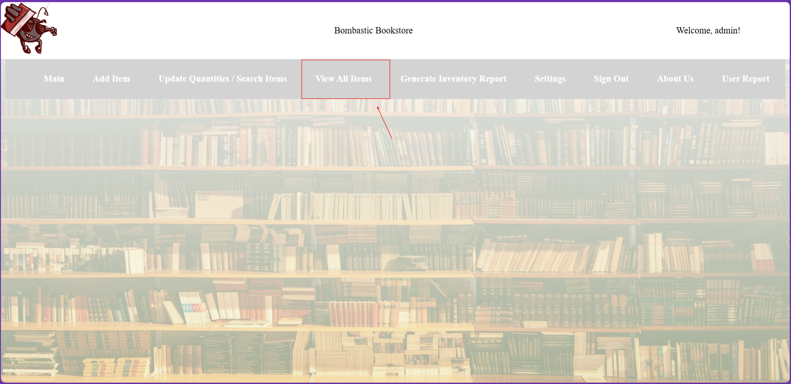

On this page you can view all the items in inventory.

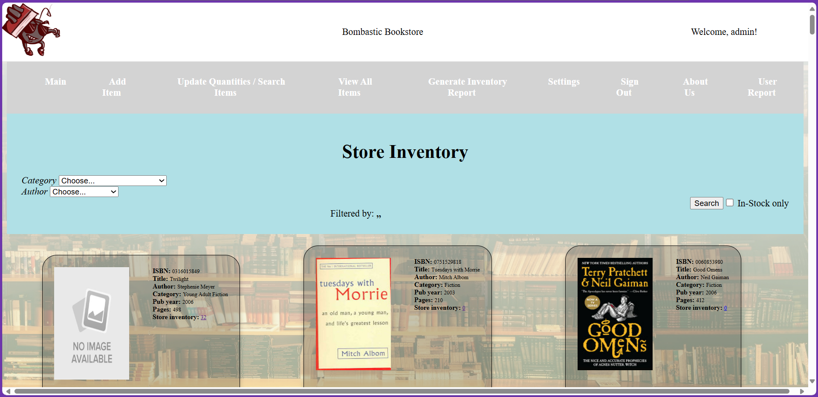

1. Click on the number link next to store inventory on the card showing book information.



1. Here you will arrive at the prompt to update the quantity of books in the inventory

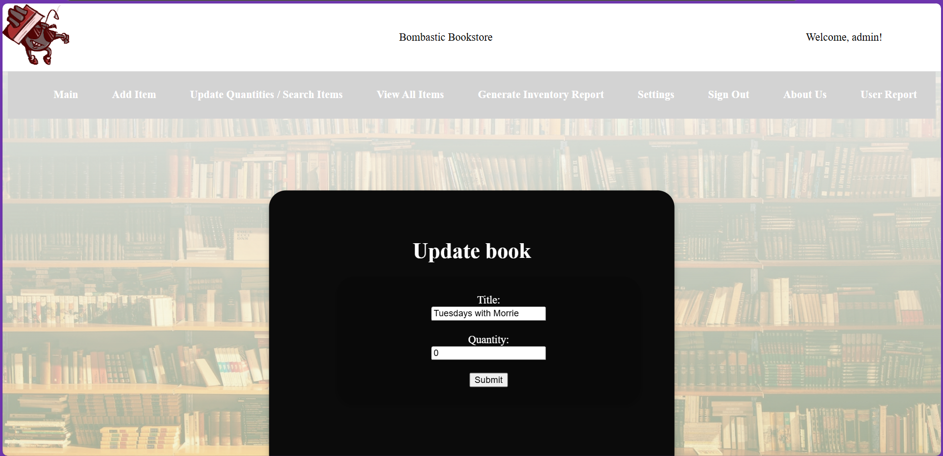

1. Enter the new number of books in the Quantity box and press submit.

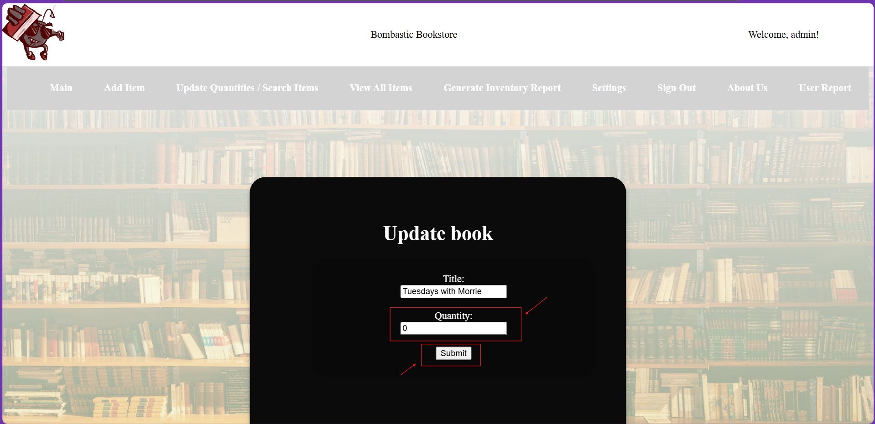

**Settings**

In the navigation bar click on settings, here you can change your email, password, and theme.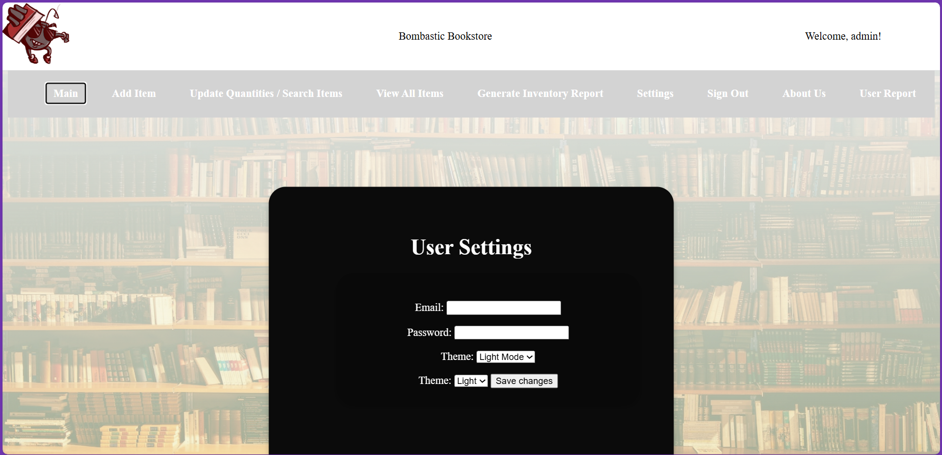

**User Report**

In the navigation bar click on the User Report tab. This page shows who has signed in to the management system as well as when they signed up and when they last logged in. 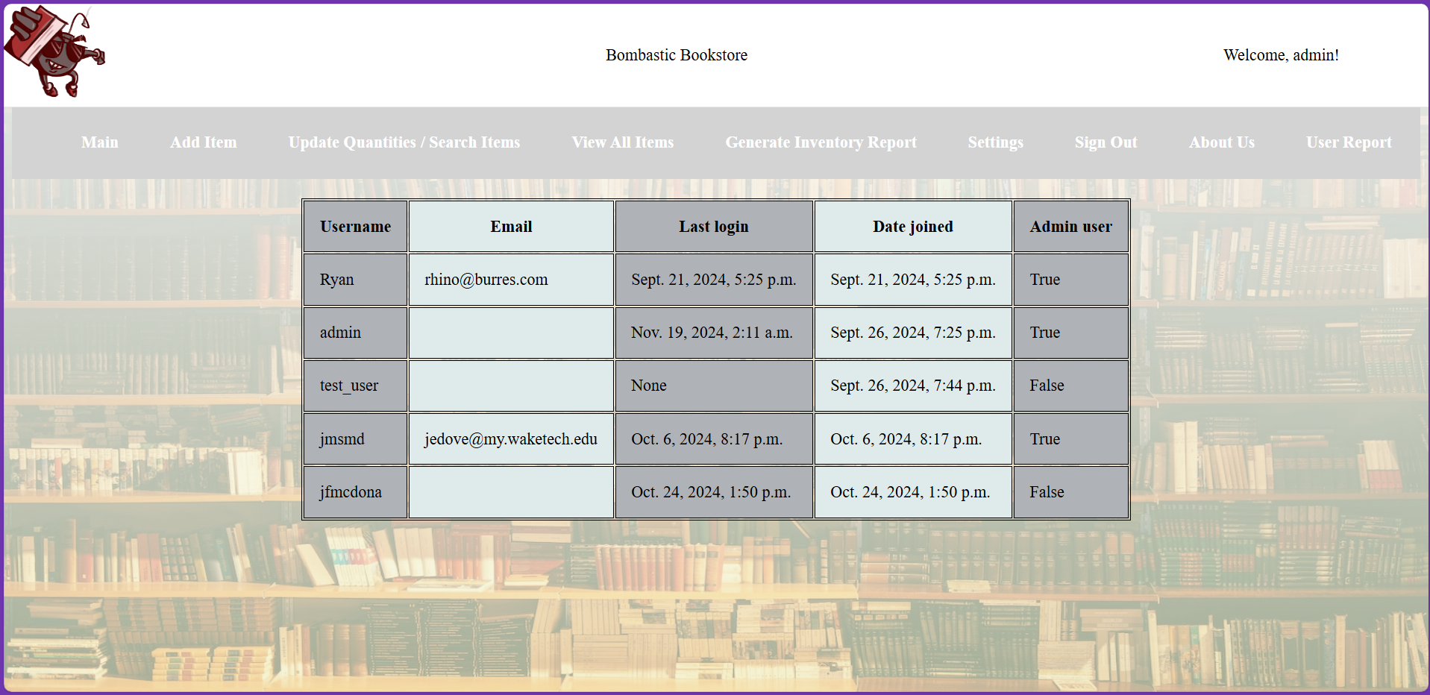

**About Us**

In the about us page you can learn more about our team as well as the purpose of this application. 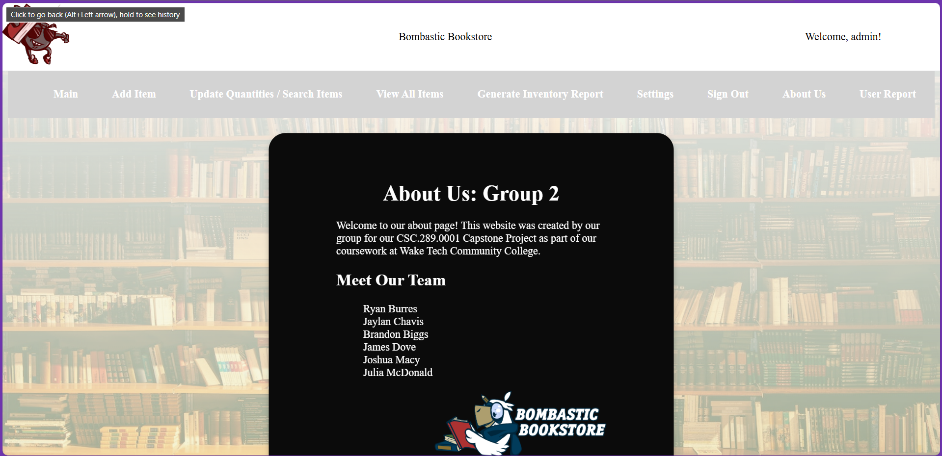

**Troubleshooting**

**Common Problems**

* If the login page does not load when trying to run the application, the wrong link was used. Make sure this link is used to get to the login page:

<http://localhost:8000/accounts/login/?next=/>

**FAQs**

Q: How to remove and update book data?

A: You can search for the book data you would like to update. You can then edit the title and quantity or remove the listing altogether by clicking the x in the top right corner.

Q: How do I change my password?

A: You can change your password on the settings page. You’ll need to enter your current email and password. Alternatively, you can click the forgot password button on the sign-in page. You’ll receive an email detailing how to change your password.

Q: How do I generate user reports?

A: Click the user report button on the navigation bar to view all users.

Q: How do I find book data?

A: You can find book data next to an entry by searching for a specific book to visit the view all items page.

Q: How do I view all book data?

A: Click view all on items on the navigation bar to view all inventory items.

**Support and Contact Information**

If troubleshooting your problem with our user manual has not worked or you have run into bugs we have missed contact our team:

Email TeamBombastic@gmail.com

Phone Number

919-866-5000